##### CONFIDENTIAL

**AMUL**

*The taste of India*

**Business Plan**

Prepared 24-03-2021

**Contact Information**

**Gujarat Cooperative Milk Marketing Federation Ltd.**

Amul Dairy Road,

Opp: Hotel Surabhi,

Anand- 388 001,

Gujarat, India.

**Phone:** +91-2692-258506, 258507,

258508, 258509

**FAX:** +91-2692-240208

**Email:** gcmmf@amul.coop



**Table of Contents**

**Executive Summary 1**

**Opportunity 1**

**Expectations 1**

**Opportunity 3**

**Problem & Solution 3**

**Target Market 3**

**Competition 3**

**Execution 4**

**Marketing & Sales 4**

**Operations 4**

**Milestones & Metrics 5**

**Company 6**

**Overview 6**

**Team 6**

**Financial Plan 7**

**Forecast 7**

**Financing 9**

**Statements 10**

**Appendix 13**

**Profit and Loss Statement 13****Balance Sheet 15**

**Cash Flow Statement 17**

# Executive Summary

## Opportunity

###### Problem Summary

Amul was formed as a part of a cooperative movement against Polson Dairy in Anand, Gujarat, which procured milk from local farmers of Kaira District at very low rates and sold it to the Bombay government. The result was the formation of the Kaira District Co-operative Milk Producers' Union Limited in Anand. Now the farmers were getting good prices for their product and also customers were getting milk at a genuine price.

At the present day, the problem is the availability of milk and its product at cheaper rates, increasing milk production in India and providing a good return to the farmers.

###### Solution Summary

Amul aims to provide remunerative returns to the farmers and also serve the interest of consumers by providing quality products that are good value for money. Amul is a co-operative sector. It is the institution of the farmers, from the farmers and for the farmers. It gives pleasure to the farmer to charge his own price, which was not possible in earlier years. Amul dairy has five main departments like finance, personnel, commercial, milk procurement, and production.

Some new services provided by Amul includes Ice-cream Parlour, Indian chocolates which indirectly promotes Make In India program, provide jobs in the dairy industry and constant earning to farmers. Also, maintenance of the quality of the product is what makes it popular and getting an increase in demand.

###### Market

The segmentation of Amul is the mass population and in general, you will find people of all different age groups and demography enjoying Amul products. This is because Amul is not only present in Ice cream, but also in Milk, Butter, Cheese, and other such products.

As it has a very deep product portfolio, it does not differentiate in its customers but uses a mass marketing principle. And till date, this principle has worked very well for the marketing strategy of Amul. Similarly, the target audience is regular middle-class people. It uses the tagline “The taste of India” to make customers feel oneness.

Amul has made a market of not only human use but also for animals, ‘Amul Power Dan’ produces Maize Cattle Feed.paddy Straws, Alfalfa Hay, .Buffalo Feed, .Chana Churi, .Soya Lecithin Cattle Feed, .Feed Molasses, .Guar Meal.etc for better health of animal and better production

###### Competition

The top 10 competitors in Amul's competitive set are Mother Dairy, Prabhat Dairy Ltd., Osam Dairy, Chitale Dairy, Gowardhan, Kwality Wall, Adityaa Milk, Mars, Hershey, Britannia Industries Limited.

There are two major competitive advantages of Amul over other brands. First and foremost is the supply chain. Because of the large number of dairy suppliers, Amul has tremendous strength and reliability in its supply chain. Hence, it is able to produce such high volumes. The second competitive advantage is the wide product portfolio due to which it can run Amul shops and also have its products present in retail. The product portfolio is such that products like Butter and Ice cream are cash cows for the company.

Some new competitors include Baskin Robins in the Ice Cream Parlour sector and all the chocolate companies as Amul is now growing chocolate production.Amul uses a healthy competing methodology, Amul made Indian milk sufficient by lifting up from the stage of milk deficiency.

###### Why Us?

###### Amul is only the one who on such a large scale helping farmers working as a cooperative.

Chairman of Amul Shri Ramsinh Parmar is a well known cooperative sector leader and seven time former MLA .Thus he carries an ample amount of experience with him.

CEO of Amul Mr R.S. Sodhi holds a bachelor’s degree in Engineering from CTAE, Udaipur. He then joined the Institute of Rural Management Anand (IIRMA) to get his degree of MBA. He started his career for the dairy giants Amul as a senior manager for sales and operations.As the brand name is easily recognizable, but the man behind such an acclaimed success story has to be undoubtedly Mr. R.S Sodhi.

Rupinder’s association for the dairy giants as a prominent personal has been for ages now. The significant contribution to the milk cooperative from Mr. Sodhi came when he visioned a plan for the distribution network. His plan of making a network of “Super Distributors” or in other words special distributors, was to ensure that Amul reaches the home of even the rural most parts of India. The same opened up endless possibilities to increase the distribution network even further which would end up opening new employment opportunities for millions.

## Expectations

###### Forecast

Rupinder Singh Sodhi(CEO of Amul) said they have set a target of doubling turnover to Rs 1 lakh crore by 2024 from Rs 52,000 crore(in the session 2019-20) by procuring more, processing more, and marketing more. “This year we will be investing Rs 1,000 core and we will be investing around Rs 5,000 crore in the next five years in expanding milk processing infrastructure,” Sodhi said. In the long term, Amul aims to establish itself as the largest dairy organization in the world—it currently ranks ninth, GCMMF said after its 45th annual general meeting held at Anand, Gujarat.

###### Financial Highlights by Year

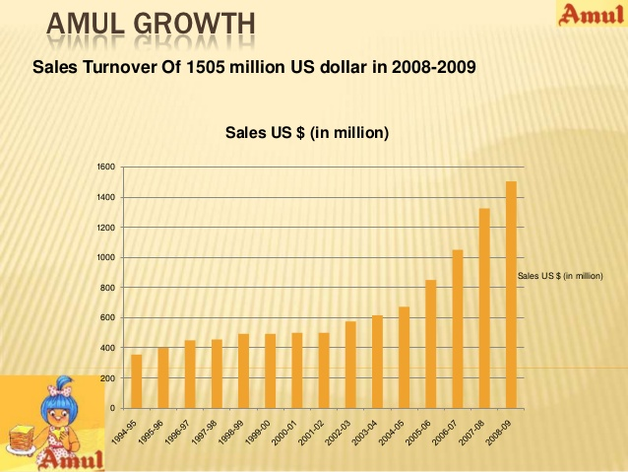

Amul from its very age made and steady exponential growth this can be observed from the above plot and in the plot below is displaying the growth in the very recent year. Amul has made a long journey . reported a 17% increase in turnover to Rs 38,550 crore in the year ended March 31. The Amul group's turnover exceeded Rs 50,000 crore, which is also 17% higher than last year.This is all because of a good planning, strategy , coordination and dedication to the betterment of Amul and its farmers, also its customers.

Although we can observe an increase in expenses in the figure below, still the net profit graph shows a rise.

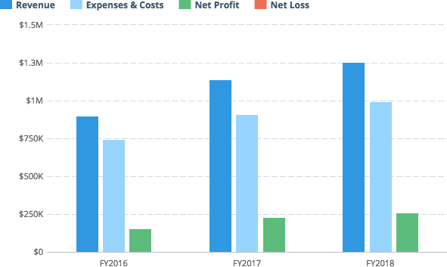

###### Financing Needed

1. As the products are sold on a daily basis to Gujarat Cooperative Milk Marketing Federation (GCMMF). An amount is given by the federation to the union so that it gets paid for the sale of its products.

2. The societies that are involved in its functioning hold fixed deposits that act as a major source of capital.

3. As these Fixed deposits release some kind of Interest when deposited in banks like UTI, BOB, etc. These act as another source of finance.

4. The share capital is not public hence it is not listed in the market it is exclusively for the members of the society.

5. A need for financing for the expansion purpose, to compete with the other multinational companies

# Opportunity

## Problem & Solution

###### Problem Worth Solving

1.Amul has competition from local co-operatives in milk .

2 .[Amul](http://www.amul.com/m/organisation) was founded in 1946 in Anand, Gujarat with a mission to stop the exploitation of the farmers by middlemen.The operational cost for Amul is enormous this becomes a liability for the company as Amul experiences multiple price changes and is dependent on its farming unions and community whose needs are growing every day. Amul does not have an effective mechanism in place to face these challenges which is risky given the unpredictability of supply.

3..Amul has diversified its dairy products variety, but it has not experienced similar success in its other productions. The best example is its chocolate products that have not reached the same level of success as its ice creams. Amul’s portfolio expansion is crucial for its brand image.

###### Our Solution

1.Amul made expansion in milk procurement, processing and distributions because of which the profits of the company increased and the farmers were no more exploited by middlemen and they were getting good value for money.

2. This pricing strategy of Amul made it affordable for its target audience. Increasing the price of goods proportional to their audience’s increase in income helped them retain their customer base. A competitive pricing strategy, such as a one-on-one offer, was adopted for products facing heavy competition.As Amul is a co-operative, it aimed to get the best price for the producer as well as the consumer, unlike certain companies that focused only on profit.

3.A well planned and executed logistics and supply chain model was incorporated.

At the village level, there were cooperative societies producing milk

At the district level, there were milk unions with processing centers

At the state level, there were milk federations responsible for consolidation

## 

## Target Market

###### Market Size & Segments

Amul products consist of a variety of products in varying cost ranges and are used by all classes of people, so the whole population is the target of Amul. The expectation of any customer is a quality product at an affordable cost. especially daily use items cannot have a price higher than the market.

Amul target audience contains household parts including Amul kool, chocolates, Amul milk, nutramul, energy drink, pizza cheese, Amul cheese spread, Amul lite, etc. For them, Amul advertised in such a way that these things gave a feel of homemade.

In the industrial sector, it supplies milk to ice-cream manufacturers, Restaurant, Coffee shops, Bakery, pizza, and snack retailers. They tend to use Amul the reason being consistency in the quality and demand satisfying power at a satisfactory rate.

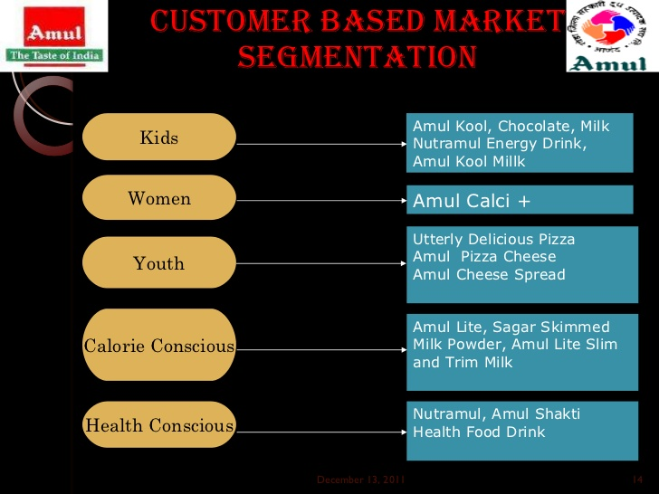

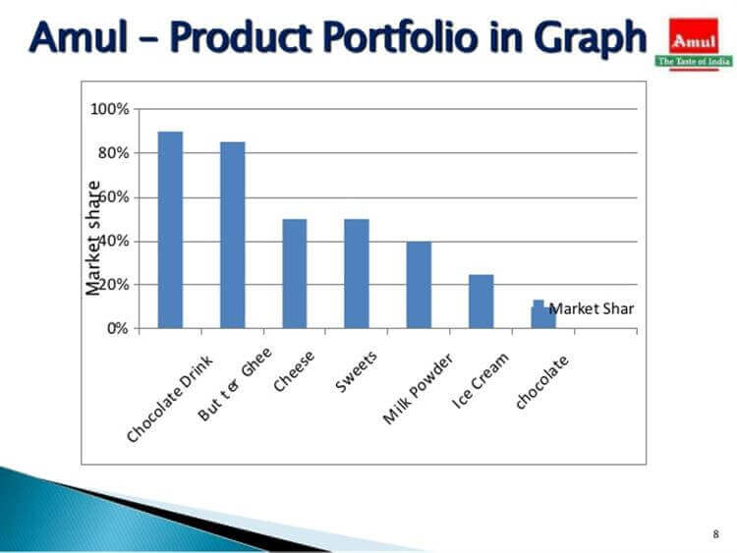

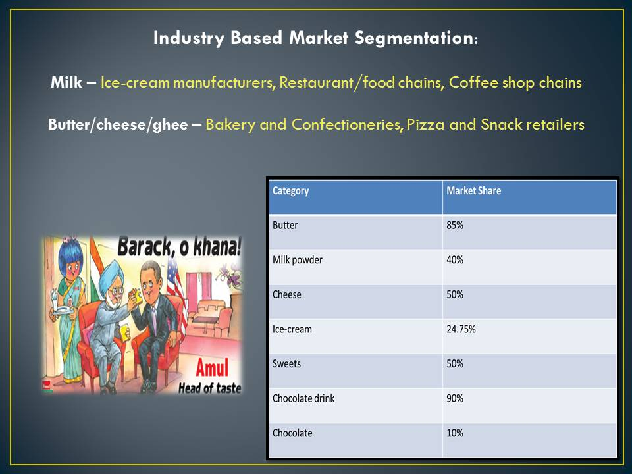

## 

## 

## 

## 

## 

## 

## 

## 

## Competition

###### Current Alternatives

Companies like Nestle,Mother Dairy ,Parag,Kwality and other companies selling milk ,ice creams

chocolates,butter and other milk products are its competitors.

Amul faces good competition with Baskin Robbins in Ice cream, Dairy Milk in chocolates , Patanjali in Ghee, etc.

Still Branding made Amul to sustain in a competitive world

###### Our Advantages

* AMUL was the first indian dairy co-operative society so it have pre established network for marketing sale,
* AMUL introduced new products gradually and always moved with the trend because of which the revenue of the company increased exponentially.
* AMUL increased the procurement of milk and made processing faster and expanded its distribution and branding of the product.
* Expanding product portfolio is a powerful distribution channel, which includes 8,500 exclusive amul parlours.
* Amul is run under a cooperative society GCMMF that makes Amul trustworthy, accountable and more progressive.
* Amul team is motivated for society instead of money, 80%, of the profit is gained by the farmers
* Being cooperative, not a big investment is required in comparison to private also management work got easy, raw materials suppliers take care of all of these.

# Execution

## Marketing & Sales

###### Marketing Plan

Some business strategy of Amul or marketing plan of Amul:

* Content Marketing
* Branding.
* Product portfolio.
* Product Pricing.
* 25-percent Advertising.
* Digital Marketing.

Amul uses Content Marketing also to advertise their brand, under this Amul regularly posts on Social issues or events. Amul has recognised that a good reach to traffic can be made using content marketing, under which a company instead of only talking about its product talks about Events may be not related with the product.



Above poster is an example of content marketing, of the time when Amitabh bachan recovered from corona and returned home. Amul Girl is also very famous among people, this character represents Amul society. This is how Amul very efficiently Advertises.

The first aspect of the marketing strategy of Amul is **branding**. We are all aware of Amul’s tagline- ‘The taste of India’. The tagline conveys the notion that bread and butter are a staple of only the British breakfast and pulled nationalism in. The never-aging girl who wore a polka-dotted dress, with blue hair and an orange face was the company’s icon. Amul marketed all of its products under a single name, which led to advertising merely costing one percent of its revenue.

The second aspect of Amul's marketing strategy was **Amul’s product portfolio**. Amul’s variety of products catered to a large audience. While certain brands such as London dairy, Baskin Robbins, etc., managed to

capture a few regional (ice cream) markets where they cater to high-end customers, Amul secured their standing in the overall dairy market. Their main target audience was however the middle and economic classes. The simple reason behind their retention of customers is because of the product pricing.

The third aspect is **product pricing.** It is one of the best promotional strategies adopted by Amul. It opted for a low-cost pricing strategy for products that are consumed regularly. This pricing strategy of Amul made it affordable for its target audience. Increasing the price of goods proportional to their audience’s increase in income helped them retain their customer base. A competitive pricing strategy, such as a one-on-one offer, was adopted for products facing heavy competition.

One such product line is ice cream. As Amul is a co-operative, it aimed to get the best price for the producer as well as the consumer, unlike certain companies that focused only on profit. But being an FMCG company surely involved a well-planned production, storage, and distribution network which is expensive. Yet Amul sold goods at affordable prices.

How it is done :-

A well planned and executed logistics and supply chain model was incorporated. Amul was a three-tier cooperative structure.

* At the village level, there were cooperative societies producing milk
* At the district level, there were milk unions with processing centers
* At the state level, there were milk federations responsible for consolidation

This transparent model led to maximum returns for the suppliers- the farmers. As the prices increased, their income accordingly increased as well. Also, co-operatives are one big family. Surplus products were sent to areas with high demand and vice versa. So, that was the Amul distribution strategy. All the above-mentioned factors were 75 percent. Without the 25 percent, 75 percent was as good as zero. So what was the 25 percent?

We reached the final aspect of Amul’s marketing strategy, 25 percent of Amul's advertising strategy. Without advertising, the target audience wouldn’t be aware of the existence of the product. Amul was (and still is) in the Guinness record for running the longest-ever advertising campaign. The Amul butterfly girl is now 43 years old now, although it doesn't look like it. Top of the mind positioning was achieved by Amul, meaning Amul was first thought of when it came to dairy. The butterfly girl appeared in hilarious topical representations involving butter and current affairs!

Amul also came up with several taglines such as- ‘Amul Doodh Peeta Hai India’,’ Har Ghar Amul Ghar’,’Pehla Pyaar Amul Pyaar’ and so on in its short advertisement videos. Every advertisement was guaranteed to make you chuckle appreciatively at its wit, warm your heart, or tickle your funny bone.

While not as big a presence in television ads as it used to be, the advertising strategy of Amul through digital marketing made the most of it through platforms such as Facebook, Twitter, Instagram, and others. Amul’s digital marketing strategy also made it a point to connect with its customers and take care of any and every complaint rigorously.

###### Sales Plan

When we look into the sales aspects of Amul the products are sold at distributorship at different levels, which supply products to the shops .

PRODUCTS -> AGENTS -> WHOLESALER -> RETAILER -> CONSUMER

The entire market is divided in 5 zones. The zonal offices are located at Ahmedabad, Mumbai, New Delhi, Kolkata and Chennai. Moreover there are 49 Depots located across the country and GCMMF caters to 13 Export markets. A zero level of channel also called a direct marketing channel consists of a manufacturer selling directly to the final customers.

A one level channel contains one selling intermediary such as retailers to the final customers. A two level channel two intermediaries are typically wholesaler and retailer. A three level channel is typically wholesaler, retailer and jobber in between. GCMMF has an excellent distribution. It is its distribution channel, which has made it so popular. GCMMF‟s products like milk and milk products are perishable. It becomes that much more important for them to have a good distribution.

First of all the products are stored at the Agents end who are mere facilitators in the network. Then the products are sold to wholesale dealers who then sell to retailers and then the product finally reaches the consumers.

**Amul Parlors**

Amul has come out with a unique concept of Amul Parlours. They have classified those under four types namely:

· Center for excellence

· On the Move

· Amul Parlours

· Amul Preferred

Outlets Center for Excellence: These Amul Parlours are specifically at a place, which has a class of excellence of its own. We can find such parlors at the Infosys, IIMA, NID Ahmedabad etc.

On the Move: These parlors are at the railway stations and at different state bus depots across different cities.

Amul Parlours: These parlors can be seen at different gardens across different cities. These are fully owned by Amul.

Amul Preferred Outlets: These are the private shops that keep the entire product range of Amul. They also agree not to keep any competitor brands in the outlets. They can keep other brands that are in the non-competitor category. Amul has more than 200 such outlets right now. It wants to have 1,00,000 parlors by the end of the year 2010.

During the launch of any new products amul many times manages its sale just by branding and many a time advertising or through salesperson it generates demand in the market for a good sale.

## Operations

###### Locations & Facilities

Amul has plants in many of the states still not everywhere so goods are supplied inter state also, main setup being in Gujarat, Amul also has international locations. When we look into the sales aspects of Amul then products are sold providing distributorship at different levels state, district, city, which supply products to the shops at the end of the chain. Amul recently installed many parlours which are only devoted to Amul, this is a part of branding and advertising.

Manufacturing plants are installed in Gujarat, Delhi, UP, Maharashtra, Chhattisgarh, Madhya pradesh, Assam, Rajasthan, J&k and Jharkhand. Most of these states are popular for farming.Amul uses Silos to store milk, and wareHouses for other goods. In industries like where food items are made, they do not need long storage, instead a quality storage is needed.Having Manufacturing inSo many places provide location benefits for transportation.

Amul is looking to expand all around for better production and transportation, for this Amul will need a farmer rich place, also good transportation.Day by day demand of Amul will increase and also international branches of Amul will be established.

###### Technology

Amul’s foray into the fruit juices segment follows its expansion into the frozen snacks market, leveraging its existing cold chain.In 2018 it launched products like French fries, aloo tikki and hash browns under the Happy Treats brand. “We have got the biggest frozen foods distribution highway,” said Sodhi(CEO). “Especially during winter when the production is less in segments like ice creams, he thought of buying potatoes from farmers and converting it into potato products.”

Of late, Amul has also been strengthening its chocolates business. It started pushing products aggressively only recently, especially black chocolates. A new plant on the outskirts of Anand, inaugurated last September, can produce 1,000 tonnes of chocolate a month. Currently, chocolate business contributes just around 3 percent of GCMMF’s turnover, but Sodhi sees it growing in the future. He claims Amul has already become the number one player in dark chocolates.

Mondelez International, maker of Cadbury Dairy Milk chocolate, controls more than 60 per cent of India's Rs 8,200 crore chocolate market, and is followed by multinationals Nestle and Ferrero. Homegrown consumer goods major ITC also has plans to get more aggressive in the chocolate market.

Despite the diversification plans, GCMMF’s focus continues to be on the dairy business. “The size of India’s organised dairy industry is Rs 1.7 lakh crore and Amul brand is only 25 per cent of that,” said Sodhi. “The organised industry is growing at a double-digit rate. So, our main focus will always be dairy.”

GCMMF will invest Rs 600 to 800 crore in new processing and packaging facilities every year. It has 69 plants and five more are in the pipeline. The member unions of Amul plan to enhance milk processing capacity from the current 350 lakh litres a day to 380-400 lakh litres in the next two years. In south India, a market that is dominated by strong regional players, GCMMF is looking to improve its distribution reach.

“Our turnover in 2009-10 was Rs 8,000 crore. It has grown to around Rs 33,000 crore in the financial year ending March 31, 2019. What we are looking at is that, in another 10 years, it will be around Rs 1 lakh crore,” said Sodhi(CEO).

GCMMF had exports worth Rs 800 crore in the last financial year. Sodhi(CEO) sees a big opportunity here. “Bangladesh, Sri Lanka, China and Russia, South East Asian countries and West Asia are milk deficient countries. They are importing mainly from Europe, New Zealand or Australia, while we are next door,” he said.

###### Equipment & Tools

Amul uses modern technology for milk extraction from cow to it processing in the plant, then it transfers milk to the processing centers using cold storage tanks. Quality testing equipments are used to check quality.When milk reaches processing farms they are tested before and processing, then milk are stored in silos, then they are processed for cream if for ice cream, ther wise its pasteurized and Homogenized form is sold, so Pasteurization machines, Blenders, conveyor belts , ovens , mixer tanks, Freezers, air compressors for ice cream manufacturing, robotic arms, Packaging machines all these are needed for a need of speed production.

Many products of amul are needed to be delivered regularly on time so a good processing speed play a role.So a fully automated production setup is used, Lakhs of dairy farmers use milking machine to maintain hygiene of the supplied milk, a quality checker to decide payment to suppliers of the milk to amul. Automatic milk packaging systems using conveyors and robotic arms are used from plastic pack to crates filling.Crates washing chambers need washing tanks, Also tetra packing is done which is a very high quality pack having capacity to store milk till 6 months.

Solar hot water system is used to provide hot processed water for the plant use.This is how Amul is sustainably using modern technology.

Amul had very well taken care of speed, cost , quality , technology reliability and innovations.

## Milestones & Metrics

###### Milestones

India’s milk production increased from 21.2 million metric tons in 1968-69 to 88.1 million metric tons in 2003-04. Per capita availability of milk increased from 112 grams per day in 1968-69 to 231 grams per day in 2003-04. The dairy cooperative network is owned by nearly 12 million farmer members. These producers are grouped in nearly 1,08,574 village-level dairy cooperative societies. The societies are grouped in 170 district-level unions spanning 338 districts. The unions make up 22 state-level marketing federations. In 2003-04 average daily cooperative milk marketing stood at 14.87 million litres; annual growth has averaged about 4.2 per cent compounded over the last 5 years. During the last decade, the dairy milk supply has increased from 17.5 to 52 litres per 1,000 urban consumers.

###### Key Metrics

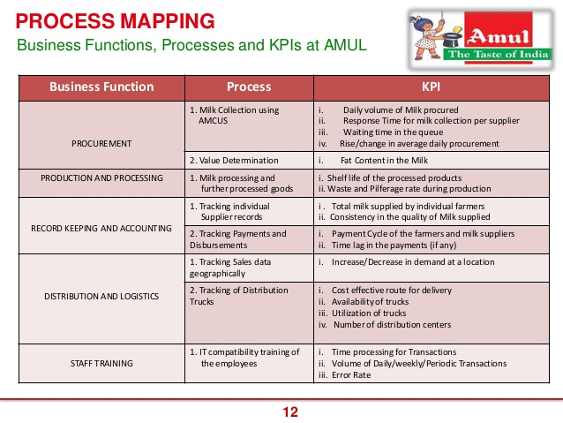

# Company

## Overview

Amul is a co-operative industry also called Anand Milk Union Limited, supplying dairy products. Jointly owned by 3.6 million milk producers of Gujarat, their contribution is varied by their supply capacity. It is managed by a cooperative body Gujarat Co-operative Milk Marketing Federation Ltd. (GCMMF). The founder of Amul is Tribhuvandas Patel.

Profit made by Amul belongs to the milk producers, if Amul earns more it will pay more to the farmers. Amul is for the betterment of farmers, providing them the right amount for the supply.

Amul share 80 % of its profit with farmers,

## Team

###### Management Team

Dr. Verghese Kurein became the chairman of Amul after the death of Tribhuvandas Patel. He is the creator of Amul girl. He was a mechanical engineer and an entrepreneur, also studied dairy engineering. In the initial stage of Amul, he looked into the processing equipment, supply, and storage. He became the first chairman.

R.S. Sodhi is the CEO of Amul, a strong business development professional who graduated from IRMA, he has been working in Amul for the last 34 years, starting from the position of senior sales manager. He looks into the expansion of Amul, he has a great contribution in increasing the turnover, adding new products, and increasing availability. He is the managing director of the Gujarat cooperative milk marketing Federation.

Pavan Singh is the Deputy managing director, also the marketing head of Amul. He has done MBA and marketing studies from IRMA. Look into the rapid growth of sales and new product innovation.

Ramsinh Parmar, Chairman of the marketing body of Amul, was elected in 2018 and re-elected in 2020. He will work under GCMMF and look into the quality and expansion of the company..

###### Advisors

Sardar Vallabh bhai patel was one who mentored the founder of amul, to start this cooperative dairy products supply company.

Zarifa Rizvi is the management consultant and corporate advisor of Amul,

Kurshid Ahmed Ganai an IAS officer called as an advisor by R.S. Sodhi, explaining the sales and marketing.

# Financial Plan

## Forecast

###### Key Assumptions

Amul is expanding it to new locations for supply, this will result in reducing the cost of manufacture and supply. Also increasing jobs, payment to every farmer. Amul brought up new seasonal selling products like Amul tru fruit juice, misti dashi in different flavours to attract food lovers, and also made its parlours look attractive.

Amul is also putting its efforts to compete with a famous brand Dairy Milk by introducing chocolates, Amul initially found tough to give a fight to Dairy milk as it is most selling chocolate in India, so Amul made its way through dark Chocolates which is not very popular everywhere in India, also Dairy milk has till now not introduced dark chocolates in India, and gained success in Dark ones .

No doubt Amul Ice-cream is the most selling one, cheap and affordable also available at good Quality and

variety from a small 5 rupees cup to Ice-cream Blocks or Cones in Amul parlours, and some other refreshment like Milkshakes(Amul cool) , Lassi , ButterMilk, etc., also some new launched bakery biscuits in the center of attraction for customers.

Projection of revenue is made keeping in mind the past results and new expansion, setting up of new amul

parlours , launching of new products like Amul Tru, Cookies, Dark Chocolates etc. Also with the growth of Population rising demand for refreshments also affects the rise in competition with companies like Mother Dairy, Baskin Robbins etc.

In today's scenario 70 % of the people prefer amul for milk, ice-cream etc according to our approximation, Amul still have a good scope in rise of customer population, although this is not only thing to focus upon Amul also looks to expand varieties to increase frequency of purchase per customers, Amul try to launch product affordable like Amul tru was launched keeping in mind the scope for a cheap energy drink. Market for Amul is evergreen and will grow no such barriers are at present to be faced. But RS Sodhi (CEO of Amul) is demanding a change in government taxes to get a quick growth looking forward for a second white Revolution.

GCMMF aims to achieve a group business turnover of Rs 1 lakh crore by 2024-25," it said in a statement after the 42nd AGM held at Anand.The GCMMF said it registered a sales turnover of Rs 38,542 crore in 2019-20, which is 17 per cent higher than the previous financial year.A rapid expansion has helped Amul record a turnover almost five times higher than Rs 8,005 crore in 2009-10, it said.

Daily milk procurement was 215.96 lakh litre per day in 2019-20, GCMMF said, quoting its Chairman Ramsinh Parmar.

###### Revenue by Month

INSTRUCTIONS: Include a chart that shows your projected revenue. A tool like [LivePlan](http://pln.rs/48) can help you create a chart like this and automatically include it in your business plan.

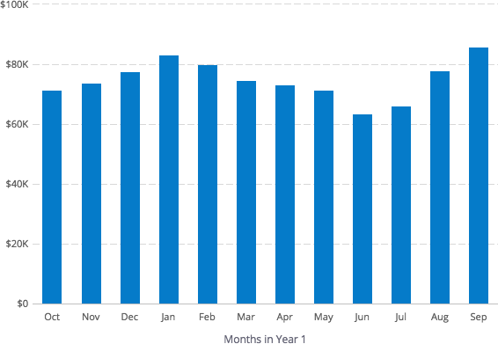

###### Expenses by Month

INSTRUCTIONS: Include a chart that shows your projected expenses. A tool like [LivePlan](http://pln.rs/48) can help you create a chart like this and automatically include it in your business plan.

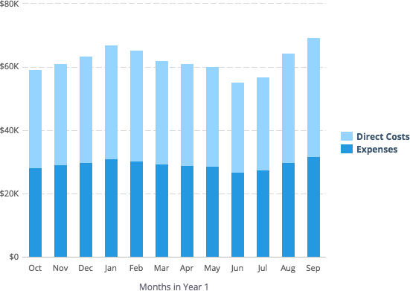

###### Net Profit (or Loss) by Year

Amul has shown a gradual and consistent progress in profit making not only on the three given years but from long before it.

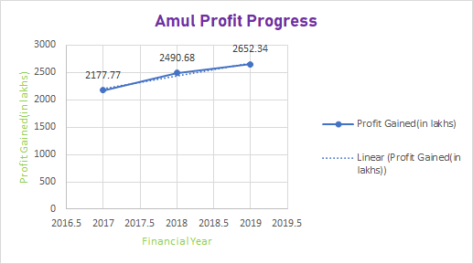

## Financing

###### Use of Funds

1.Maximize the profit –the main objective is to increase the profit as much as possible. This has to be done with keeping in mind the returns for the company.

2.“This year amul will be investing Rs 1,000 core and will be investing around Rs 5,000 crore in the next five years in expanding milk processing infrastructure” so the processing capacity would increase to 420 lakh litres per day from the current 380 lakh litres per day.

3. Amul plan to expand product range and market reach by reaching to 3,000 more small towns this year and are adding 200 super distributors,” he said. Amul will also add about 1,000 parlours to the existing 6,000 that sell all its products under one roof.amul already have few plants for edible oil, bakery and potato processing they will be investing Rs 400-500 crore on setting up more plants in these new business areas over the next two years," Sodhi said.

###### Sources of Funds

1. As the products are sold on a daily basis to Gujarat Co-operative Marketing Federation (GCMMF). An amount is given by the federation to the union so that it gets paid for the sale of its products.

2.societies that are involved in its functioning hold fixed deposits that act as a major source of cpital.

3. As these Fixed deposits release some kind of Interest when deposited in banks like UTI, BOB etc. These act as another source of finance.

4. The share capital is not public hence it is not listed in the market it is exclusively for the members of the society.

## Statements

###### Projected Profit & Loss

| **FY2017** | **FY2018** | **FY2019** |
| --- | --- | --- |
| **Revenue 600031.12** | **634578.23** | **614872.12** |
| **Direct Costs 584123.32** | **597845.78** | **564125.71** |
| **Gross Margin 0.0674** | **0.413** | **0.547** |
| **Gross Margin % 6.74** | **4.13** | **5.47** |
| **Operating Expenses** |  |  |
| **Salary 12479.96** | **13456.45** | **13956.23** |
| **Employee Related Expenses 25124.32** | **26457.8** | **27489.1** |
| **Total Operating Expenses 567889.12** | **594872.12** | **572615.32** |
| **Operating Income 4500.15** | **3500.78** | **4378.12** |
| **Interest Incurred 339.45** | **357.12** | **361.31** |
| **Depreciation and Amortization 7800.48** | **10089.87** | **10458.99** |
| **Income Taxes 13.56** | **36.25** | **276.24** |
| **Total Expenses 567889.12** | **59872.12** | **572615.32** |
| **Net Profit 4096.25** | **2687.16** | **2789.01** |
| **Net Profit / Sales 4096.25** | **2687.16** | **2789.01** |

###### Projected Balance Sheet

INSTRUCTIONS: Include your balance sheet here.

| **FY2017**  **(in lakhs)** | **FY2018**  **(in lakhs)** | **FY2019**  **(in lakhs)** |
| --- | --- | --- |
| Cash 5,350.00 | 6,000.00 | 4,810.00 |
| Accounts Receivable 330.00 | 610.00 | 320.00 |
| Inventory 57,270.00 | 76,010.00 | 77,630.00 |
| Other Current Assets 721.00 | 990.00 | 867.00 |
| **Total Current Assets 91,649.00** | **1,23230.00** | **1,22,500.00** |
| Long-Term Assets 1,889.00 | 1,807.00 | 1,823.49 |
| Accumulated Depreciation 432.09 | 147.00 | 281.36 |
| **Total Long-Term Assets 27,857.98** | **34,542.67** | **36,090.54** |
| **Total Assets 1,76030.00** | **2,25,110.21** | **2,35,661.50** |
| Accounts Payable |  |  |
| Income Taxes Payable 21.50 | 18.78 | 28.52 |
| Sales Taxes Payable |  |  |
| Short-Term Debt 35,475.22 | 53,270.00 | 53,009.21 |
| Prepaid Revenue |  |  |
| **Total Current Liabilities 1,31,619.65** | **1,70,226.53** | **1,75,809.22** |
| Long-Term Debt 22,759.55 | 28,0073.88 | 28,345.32 |
| **Total Liabilities 1,59,479.47** | **2,04,779.55** | **2,11,889.44** |
| Paid-in Capital |  |  |
| Retained Earnings 21.00 | _ | _ |
| Earnings 5,71,572.01 | 6,27,195.25 | 6,97,929.05 |
| **Total Owner's Equity 15,000.00** | **15,000.00** | **15,000.00** |
| **Total Liabilities & Equity 1,74,477.22** | **2,19,787.04** | **2,26,895.99** |

**Projected** **Cash Flow Statement**

| **FY2017(in lakhs)** | **FY2018** | **FY2019** |
| --- | --- | --- |
| **Net Cash Flow from Operations** |  |  |
| Net Profit 2,170.77 | 2,480 .68 | 2,662.34 |
| Depreciation and Amortization 8,150 .83 | 10,070.35 | 10,620.51 |
| interest expenses 5,455 | 6585 | 9,970.96 |
| Change in Inventory 13,770.8 | 18,650.90 | 1,700.29 |
| Change in advances and debtors 5,400.42 | 12,250.68 | 1,255.73 |
| Change in current liabilities and provisions 2,445 | 10,080.83 | 4,200 |
| Direct Tax paid in current year and (Tax refund received net of tax paid in py) 13,850 | 9,593.73 | 28,216.64 |
| Net amount of income tax 25.48 | 18.00 | 29.64 |
| **Net Cash Flow from Operations 13,788.06** | **26,857.86** | **21,258.92** |
| **Investing & Financing** |  |  |
| Assets Purchased or Sold 14,501.66 | 25,805.08 | 11,545.12 |
| Investments Received - | 2,195.15 | 10,802.08 |
| Change in Long-Term Debt 6,000 | 11,790.77 | 5,756.56 |
| Change in Short-Term Debt 22,250.50 | 16,973.09 | 3,450.99 |
| Dividends & Distributions 450 | 635.49 | 960.88 |
| **Net Cash Flow from Investing & Financing 14,575.29/3,650.48** | **26,825.86 /17,930.11 8** | **21,285.9 /80,777** |
| Cash at Beginning of Period 14,575.29 | 26,820.86 | 21,285.92 |
| Net Change in Cash 2,650.23 | 670.15 | 1,170.97 |
| **Cash at End of Period 5,280.56** | **5,964.71** | **4,785.74** |

# Appendix

## Profit and Loss Statement (With Quarterly Detail)

| **FY2018** | **Mar '17** | **Apr '17** | **May '17** | **Jun '17** | **Jul '17** | **Aug '17** | **Sep '17** | **Oct '17** | **Nov '17** | **Dec '17** | **Jan '18** | **Feb '18** |
| --- | --- | --- | --- | --- | --- | --- | --- | --- | --- | --- | --- | --- |
| **Revenue** |  |  |  |  |  |  |  |  |  |  |  |  |
| **Direct Costs** |  |  |  |  |  |  |  |  |  |  |  |  |
| Gross Margin |  |  |  |  |  |  |  |  |  |  |  |  |
| **Gross Margin %** |  |  |  |  |  |  |  |  |  |  |  |  |
| **Operating Expenses** |  |  |  |  |  |  |  |  |  |  |  |  |
| Salary |  |  |  |  |  |  |  |  |  |  |  |  |
| Employee Related Expenses |  |  |  |  |  |  |  |  |  |  |  |  |
| **Total Operating Expenses** |  |  |  |  |  |  |  |  |  |  |  |  |
| **Operating Income** |  |  |  |  |  |  |  |  |  |  |  |  |
| Interest Incurred |  |  |  |  |  |  |  |  |  |  |  |  |
| Depreciation and Amortization |  |  |  |  |  |  |  |  |  |  |  |  |
| Income Taxes |  |  |  |  |  |  |  |  |  |  |  |  |
| **Total Expenses** |  |  |  |  |  |  |  |  |  |  |  |  |
| **Net Profit** |  |  |  |  |  |  |  |  |  |  |  |  |
| **Net Profit / Sales** |  |  |  |  |  |  |  |  |  |  |  |  |

**Profit and Loss Statement (Annual Detail)**

| **FY2017(in Lakhs)** | **FY2018(in Lakhs** | **FY2019** |
| --- | --- | --- |
| **Net Revenue From Operations 570031.55**  **other income 1538.63**  **Total income 571570.18** | **625625.62**  **1568.82**  **627194.44** | **696633.72**  **1297.05**  **697930.77** |
| **Direct Costs 555883.58**  **Cost of Material consumed 505202.96** | **625523.71**  **566034.15** | **674040.2**  **605188.27** |
| **Gross Margin 0.0649** | **0.03267** | **0.05678** |
| **Gross Margin % 6.49** | **3.267** | **5.678** |
| **Operating Expenses** |  |  |
|  |  |  |
| **Employee Related Expenses 12479.96**  **Manufacturing expenses 29250.30** | **13744.54**  **353550.65** | **1396.16**  **41400.87** |
| **Finance cost 5845.02**  **Others 23591.4**  **Total operating Expenses 568474.38** | **6597.49**  **25949.98**  **623260.99** | **9973.96**  **18060.69**  **695278.58** |
| **Operating Income 3095.80** | **3933.45** | **4261.19** |
|  |  |  |
| **Depreciation and Amortization 8157.83** | **10071.35** | **10597.51** |
| **Income Taxes 11.49** | **37.10** | **342.67** |
| **Total Expenses 568474.38** | **623260.99** | **695278.58** |
| **Net Profit 2177.77** | **2490.68** | **2652.34** |
| **Net Profit / Sales 2177.77** | **2490.68** | **2652.34** |

**Balance Sheet (With Monthly Detail)**

**FY2018 Mar**

**Apr '17 May '17 Jun '17 Jul '17 Aug '17 Sep '17 Oct '17 Nov '17 Dec '17 Jan '18 Feb '18**



Cash

Accounts Receivable Inventory

Other Current Assets

**Total Current Assets**

Long-Term Assets Accumulated Depreciation **Total Long-Term Assets**

**Total Assets**

Accounts Payable Income Taxes Payable Sales Taxes Payable Short-Term Debt Prepaid Revenue

**Total Current Liabilities**

Long-Term Debt

**Total Liabilities**

Paid-in Capital Retained Earnings Earnings

**Total Owner's Equity**

**Total Liabilities & Equity**

**Balance Sheet (Annual Detail)**

| **FY2017(in lakhs)** | **FY2018(in lakhs)** | **FY2019(in lakhs)** |
| --- | --- | --- |
| Cash 5,285.56 | **5,969.71** | **4,790.74** |
| Accounts Receivable 327.65 | **608.13** | **317.42** |
| Inventory 57,261.70 | **75,918.60** | **77,623.89** |
| Other Current Assets 720.15 | **989.13** | **866.07** |
| **Total Current Assets** 91,640.13 | **1,23,221.87** | **1,22,493.46** |
| Long-Term Assets 1,874.83 | **1,807.33** | **1,828.39** |
| Accumulated Depreciation 435.19 | **146.88** | **282.37** |
| **Total Long-Term Assets** 27,854.16 | **34,543.88** | **36,090.92** |
| **Total Assets 1,76,028.00** | **2,25,108.32** | **2,35,661.47** |
| Accounts Payable |  |  |
| Income Taxes Payable 21.48 | **18.83** | **28.64** |
| Sales Taxes Payable |  |  |
| Short-Term Debt 35,478.38 | **53,263.02** | **53,005.52** |
| Prepaid Revenue |  |  |
| **Total Current Liabilities**   1,31,622.37 | **1,70,233.89** | **1,75,802.10** |
| Long-Term Debt 22,757.91 | **28,073.27** | **28,342.23** |
| **Total Liabilities**  1,59,476.53 | **2,04,777.77** | **2,11,893.02** |
| Paid-in Capital |  |  |
| Retained Earnings 20.88 | **-** | - |
| Earnings 5,71,570.18 | **6,27,194.44** | **6,97,930.77** |
| **Total Owner's Equity 15,000.00** | **15,000.00** | **15,000.00** |
| **Total Liabilities & Equity 1,74,476.53** | **2,19,777.77** | **2,26,896.02** |

**Cash Flow Statement (With Monthly Detail)**

**FY2018 Mar**

**Apr '17 May '17 Jun '17 Jul '17 Aug '17 Sep '17 Oct '17 Nov '17 Dec '17 Jan '18 Feb '18**



**Net Cash Flow from Operations**

Net Profit

Depreciation and Amortization

Change in Accounts Receivable

Change in Inventory

Change in Accounts Payable

Change in Income Tax Payable

Change in Sales Tax Payable Change in Prepaid Revenue

**Net Cash Flow from Operations**

**Investing & Financing**

Assets Purchased or Sold Investments Received Change in Long-Term Debt Change in Short-Term Debt Dividends & Distributions

**Net Cash Flow from Investing & Financing**

Cash at Beginning of Period

Net Change in Cash

**Cash at End of Period**

**Cash Flow Statement (Annual Detail)**

| **FY2017(in lakhs)** | **FY2018** | **FY2019** |
| --- | --- | --- |
| **Net Cash Flow from Operations** |  |  |
| Net Profit 2,177.77 | 2,490 .68 | 2,652.34 |
| Depreciation and Amortization 8,157 .83 | 10,071.35 | 10,597.51 |
| interest expenses 5,451 | 6597.49 | 9,973.96 |
| Change in Inventory 13,777.8 | 18,656.90 | 1,705.29 |
| Change in advances and debtors 5,411.42 | 12,240.68 | 1,254.73 |
| Change in current liabilities and provisions 2,425 | 10,078.83 | 4,201.59 |
| Direct Tax paid in current year and (Tax refund received net of tax paid in py) 13,823 | 9,593.73 | 28,216.64 |
| Net amount of income tax 21.48 | 18.83 | 28.64 |
| **Net Cash Flow from Operations 13,598.06** | **26,827.86** | **21,288.92** |
| **Investing & Financing** |  |  |
| Assets Purchased or Sold 14,531.66 | 25,835.08 | 11,546.12 |
| Investments Received - | 2,195.15 | 10,802.08 |
| Change in Long-Term Debt 6,000 | 11,781.77 | 5,726.56 |
| Change in Short-Term Debt 22,203.50 | 16,873.09 | 3,453.99 |
| Dividends & Distributions 459 | 637.49 | 964.88 |
| **Net Cash Flow from Investing & Financing 14,577.29/3,651.48** | **26,827.86 /17,937.11 21,288.9 /80,78** |  |
| Cash at Beginning of Period 14,577.29 | 26,827.86 | 21,288.92 |
| Net Change in Cash 2,672.23 | 684.15 | 1,178.97 |
| **Cash at End of Period 5,285.56** | **5,969.71** | **4,790.74** |

